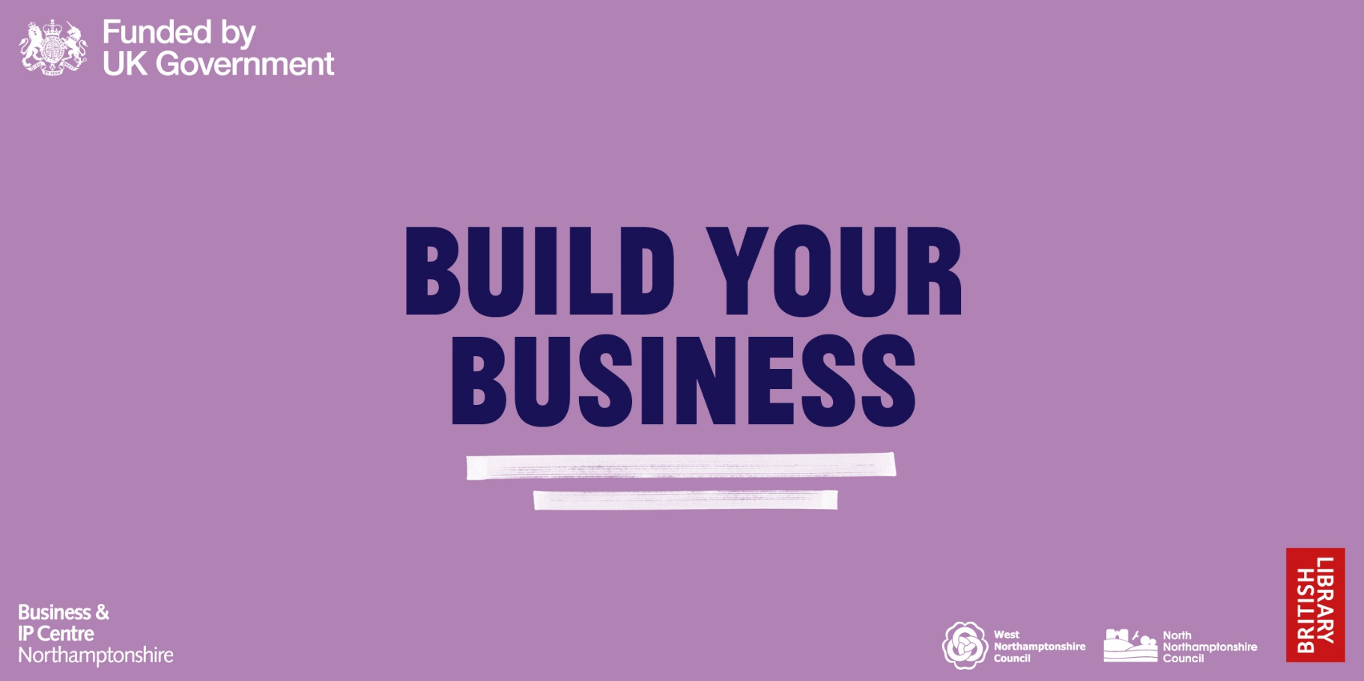

Business plan template

[Insert Business Logo & Name]
  - [Insert your full name]

Contents
Business Description 3
Executive Summary 3
Business aims/objectives 4
All about you: 4
What are you going to offer/sell? 4
Market and Customers 5
Who are your target customers? 5
Key market findings (desk) 5
Key market findings (field) 6
Who are your top 3 main competitors? 6
What is your competitive advantage/unique selling point? 6
Pricing Strategy 6
Advertising and promotion plan 7
SWOT analysis 7
Operations 8
Staffing/skills 8
Key resources and equipment 8
Costs 8
Location/route to market 8
Legal considerations 9
Financials, Risks and Sensitivities 10
Personal Survival Budget 10
Start-up business expenses 11
Cashflow Forecast 12

Information in grey boxes, such as this, will provide you with guidance to complete the business plan. This, along with the red text, should be deleted before being submitted externally.

The information next to this icon confirms the score weighting and what we will be looking for when shortlisting.
This information next to this icon will signpost you to free BIPC resources that may be useful to you when completing that section.
If you require further help or guidance with the creation of your business plan please contact the BIPC Northamptonshire team, or find out more about the resources available at www.bipcnorthamptonshire.co.uk

Business Description

Executive Summary
The executive Summary should give a short overview of the rest of the plan, and the business idea as a whole. Please sell yourself and your business or business idea to us. Give us a clear and comprehensive overview of your business.

The executive Summary should include an overview of the forecasted financial performance for years 1, 2 & 3 of trading, using narrative and the following table.
 | Year 1 | Year 2 | Year 3
Total Sales
Total Expenditure
Total Profit

Business aims/objectives
You could include a timeline of goals you aim to achieve.

All about you:
Describe your reasons for starting & running your own business. What are your personal passions and motivations to make the business succeed?

What are you going to offer/sell?
Is this a product, service, or both? Please provide a description of the basic product/service you are going to sell/offer.

What are the features and benefits of your products / services? Why are these important to your customer? List at least 3 features and benefits below.
Features | Benefits
1 | 1
2 | 2
3 | 3

Market and Customers
Key areas for consideration:
- Your understanding of your target market
- How effectively you identify the current market size in which you intend to compete and its potential for growth.
- How effectively you analyse the nature of competition within the market
- Your product/services’ revenue and pricing model and how it fares against the competition
- Does the business plan include an appropriate promotional strategy that is realistic when compared to the assigned marketing budget?
Resources
- There are a range of market research resources available through the BIPC which can be found by visiting Market Research | Databases | Business & IP Centre Northamptonshire (bipcnorthamptonshire.co.uk)
- Live workshop and webinar sessions titled ‘How To Research My Market’ which can be booked by visiting Events | Business & IP Centre Northamptonshire (bipcnorthamptonshire.co.uk)

Who are your target customers?
Are they individuals, businesses, or both? (Why have you chosen this route?)

What does a typical customer profile/avatar look like? Where are they based etc?

Why would they buy your product/service? What are their needs?

Key market findings (desk)
Provide the most relevant information here about your market. This could include:
The size of your market - is it growing, shrinking or static?

What percentage of the market do you think you will be able to reach? (And why)

How will you be able to grow your market share?

If you believe that you have something new/innovative, how do you know that there is a market for it?

Key market findings (field)
What have you learned by speaking with / surveying your customers? Explain the methods you have undertaken to find out this information.

If you have already sold to your customers, what have you learned about their buying habits / feedback?

Do you have customers waiting to buy from you?

Who are your top 3 main competitors?
Complete the table below which includes details of your top 3 competitors
Name, Location and business size | Product/Service | Price | Strengths | Weaknesses

What is your competitive advantage/unique selling point?
Describe the unique or distinguishing factors that will help your business plan succeed based on the competitors table above. Why are these factors important to your customers?

Why will your customers choose to buy from you over your competitors?

Pricing Strategy
How much are you charging for your product? Give an overview of the main products you expect to sell if your business offers more than one.

How did you decide on these figures?

Advertising and promotion plan
How do you plan to make customers aware of your business and track its success? Complete the table below. Add more rows if necessary.
Type of advertising or promotion | Success will be measured by | Time scale for implementation | Method used by competitors? (Yes/No) | Budget (£)
 |  |  | TOTAL | £

SWOT analysis
Create a SWOT analysis highlighting at least 3 Strengths & Weaknesses (internal factors) as well as 3 Opportunities & Threats (external factors) that will affect your business.
Strengths  1.  2.  3. | Weaknesses  1.  2.  3.
Opportunities  1.  2.  3. | Threats  1.  2.  3.

Operations
Key considerations for this section
- Your skills / access to skills that will fulfil the needs of this business plan
- The strength of your understanding when it comes to the requirements for this business
Resources
- We recommend looking at COBRA which could support you with completing this section. COBRA can be accessed by visiting - Market Research | Databases | Business & IP Centre Northamptonshire (bipcnorthamptonshire.co.uk)

Staffing/skills
Why are you the best person to be leading this business?

What key skills do you and your staff have?

What key skills are missing and how will your business bridge the gap?

Key resources and equipment
What are the key resources and equipment required for your business to get started/be operational?

Which suppliers will your business buy from? Why have these suppliers been chosen?

Costs
What are the main start up costs for your business?

What are the main fixed costs (overheads) for your business?

What are the main variable costs for your business, ie how much will your main products and services cost to buy / produce?

Location/route to market
Where will you operate from?

Will you have dedicated premises and/or operate online? (And why)

How will customers access/buy what you’re selling?

Legal considerations
Are there any key legal requirements that you need to meet? For Example:
Insurance cover:

Business Trading Regulations:

Intellectual Property:

Company Legal Structure: (Sole trader/limited company/partnership/Community Interest Company)

Financials, Risks and Sensitivities
Key considerations for this section:
- Does the plan include detailed sales and cash flow forecasts?
- How much money does the business need to make to pay you the required wage?
- Does the plan identify the nature of potential returns?
- Are the financial forecasts realistic?

Include a detailed commentary of your cash flow forecast, explaining the rationale behind the estimates and any areas where you feel the business may be vulnerable.
This section requires narrative in addition to the templates below.

Personal Survival Budget
Please edit the table where necessary
Expense Type | Value (£)
Rent / Mortgage
Council Tax
Utilities
Home Insurance
Car – Petrol
Car – Tax & Insurance
Car – Maintenance
Food
Clothes
Fun Money
Hair Cut
Birthdays / Christmas
Total Survival Expenses

Start-up business expenses
Please edit the table where necessary
Expense Type | Value (£)
Business Licenses
Incorporation Expenses
Deposits
Bank Account
Rent
Interior Modifications
Equipment/Machinery Required:
Item 1
Item 2
Item 3
Insurance
Stationery/Business Cards
Brochures
Pre-Opening Advertising
Stock
Other (list):
Item 1
Item 2
Total Startup Expenses

Cashflow Forecast
Please edit the table where necessary
Month | Pre-start | 1 | 2 | 3 | 4 | 5 | 6 | 7 | 8 | 9 | 10 | 11 | 12 | Total
Month name
Money coming in (£)
Sales income
Personal funding
External funding (loan etc)
Grant funding
Other
Total Money in (£) | 0 | 0 | 0 | 0 | 0 | 0 | 0 | 0 | 0 | 0 | 0 | 0 | 0 | 0
Money going out (£)
Start Up Costs
Fixed Costs
Rent
Utilities
Payroll
Expense 1
Expense 2
Expense 3
Variable Costs
Stock
Delivery
Paypal Fees
Expense 1
Expense 2
Expense 3
Total money out (£) | 0 | 0 | 0 | 0 | 0 | 0 | 0 | 0 | 0 | 0 | 0 | 0 | 0 | 0
Balance | 0 | 0 | 0 | 0 | 0 | 0 | 0 | 0 | 0 | 0 | 0 | 0 | 0 | 0
Opening balance | 0 | 0 | 0 | 0 | 0 | 0 | 0 | 0 | 0 | 0 | 0 | 0 | 0 | 0
Closing balance | 0 | 0 | 0 | 0 | 0 | 0 | 0 | 0 | 0 | 0 | 0 | 0 | 0 | 0
Assumptions
Please tell us, briefly, how you have come up with the figures above (e.g. what are your monthly/quarterly sales figures based on? Are costs actual, research or estimated? Seasonal trends etc.)

